**Practical 4**

**AIM:** Practical of Analysis of Variance.

Q1) The Company is analyzing time to complete MIS report between two groups of employees

Group 1 Experience (0-1 Years)

Group 2 Experience (1-2 Years)

|  |  |
| --- | --- |
| **G1** | **G2** |
| 85 | 83 |
| 95 | 85 |
| 105 | 96 |
| 85 | 94 |
| 90 | 102 |
| 97 | 100 |
| 104 | 94 |
| 95 | 95 |
| 88 | 88 |
| 90 | 92 |
| 94 | 95 |
| 95 | 94 |
|  | 95 |
|  | 90 |

Perform the appropriate test to check the equality of variances for two group.

**NULL HYPOTHESIS:**

HO: **σ12=σ22**

Where:

σ12 = the variance of Group 1 (Experience 0-1 Years)

σ22 = the variance of Group 2 (Experience 1-2 Years)

**ALTERNATIVE HYPOTHESIS:**

H1: **σ12 ≠σ22**

**OUPUT:**

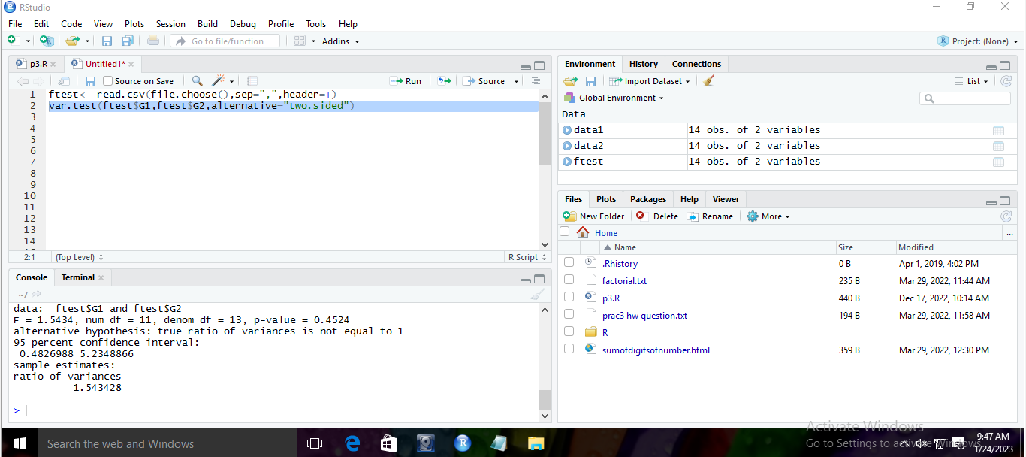

**CONCLUSION:**

Here p value is 0.4524 which is greater than 0.05, so we **accept** the null hypothesis Ho i.e variance of both the groups are equal.

Q2) A large company is assessing the difference in “Satisfaction Index” of employees in Finance, Marketing and Client-Servicing Departments.

The Index was measured on 37 employees:

|  |  |
| --- | --- |
| **satindex** | **dept** |
| 75 | Finance |
| 56 | Finance |
| 72 | Finance |
| 59 | Finance |
| 62 | Finance |
| 66 | Finance |
| 67 | Finance |
| 71 | Finance |
| 59 | Finance |
| 62 | Finance |
| 66 | Finance |
| 58 | Finance |
| 58 | Marketing |
| 63 | Marketing |
| 53 | Marketing |
| 74 | Marketing |
| 77 | Marketing |
| 69 | Marketing |
| 57 | Marketing |
| 70 | Marketing |
| 68 | Marketing |
| 51 | Marketing |
| 64 | Marketing |
| 55 | Marketing |
| 72 | CS |
| 69 | CS |
| 77 | CS |
| 71 | CS |
| 59 | CS |
| 70 | CS |
| 67 | CS |
| 73 | CS |
| 74 | CS |
| 60 | CS |
| 62 | CS |
| 65 | CS |
| 76 | CS |

Finance (n1=12), Marketing (n2=12) and Client-Servicing (n3=13)

Perform one-way ANOVA to compare equality of mean satisfaction index for 3 departments.

**NULL HYPOTHESIS:**

H0: μ1 = μ2 = μ3

Where:

μ1 = the mean satisfaction index for employees in the Finance department

μ2 = the mean satisfaction index for employees in the Marketing department

μ3 = the mean satisfaction index for employees in the Client-Servicing department

**ALTERNATIVE HYPOTHESIS:**

H1: μ1 ≠ μ2 or μ1 ≠ μ3 or μ2 ≠ μ3 (i.e. at least one of the Mean Satisfaction index will be different)

**OUPUT:**

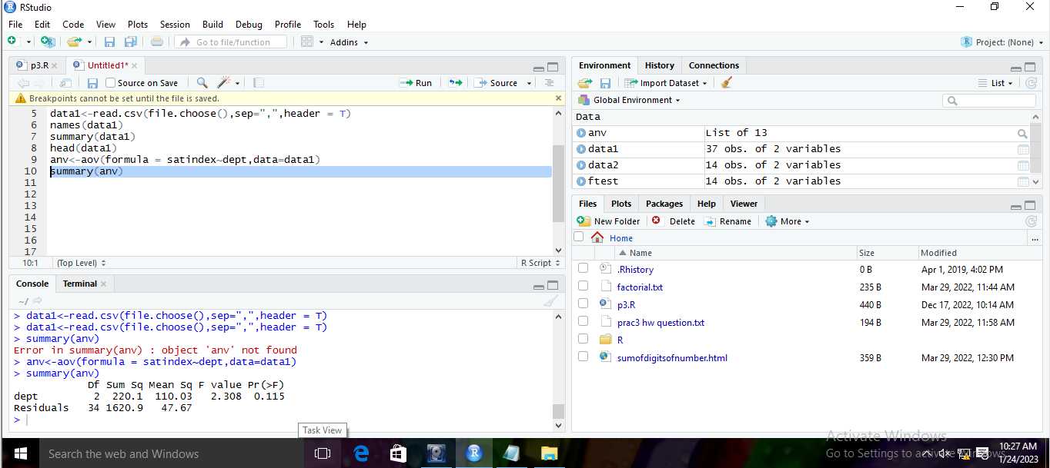

**CONCLUSION:**

Since, p value=0.115 which is greater than 0.05, so we **accept** the null hypothesis Ho i.e Mean Satisfaction Index of all 3 Departments are equal.

Q3) State the hypotheses and do the two way ANOVA test to given dataset.

|  |  |  |
| --- | --- | --- |
| **satindex** | **dept** | **exp** |
| 75 | Finance | lt5 |
| 56 | Finance | lt5 |
| 72 | Finance | lt5 |
| 59 | Finance | lt5 |
| 62 | Finance | lt5 |
| 66 | Finance | lt5 |
| 67 | Finance | lt5 |
| 71 | Finance | lt5 |
| 59 | Finance | lt5 |
| 62 | Finance | lt5 |
| 66 | Finance | lt5 |
| 58 | Finance | lt5 |
| 58 | Marketing | lt5 |
| 63 | Marketing | lt5 |
| 53 | Marketing | gt5 |
| 74 | Marketing | gt5 |
| 77 | Marketing | gt5 |
| 69 | Marketing | gt5 |
| 57 | Marketing | gt5 |
| 70 | Marketing | gt5 |
| 68 | Marketing | gt5 |
| 51 | Marketing | gt5 |
| 64 | Marketing | gt5 |
| 55 | Marketing | gt5 |
| 72 | CS | gt5 |
| 69 | CS | gt5 |
| 77 | CS | gt5 |
| 71 | CS | gt5 |
| 59 | CS | gt5 |
| 70 | CS | gt5 |
| 67 | CS | gt5 |
| 73 | CS | gt5 |
| 74 | CS | gt5 |
| 60 | CS | gt5 |
| 62 | CS | gt5 |
| 65 | CS | gt5 |
| 76 | CS | gt5 |

**NULL HYPOTHESES:**

H0: There is no significant difference in the mean satisfaction index between the departments (Finance, Marketing, and Client-Servicing).

H0: There is no significant difference in the mean satisfaction index between the experience levels (less than 5 years and greater than 5 years).

**ALTERNATIVE HYPOTHESES:**

H1: There is a significant difference in the mean satisfaction index between the departments.

H1: There is a significant difference in the mean satisfaction index between the experience levels.

**OUPUT:**

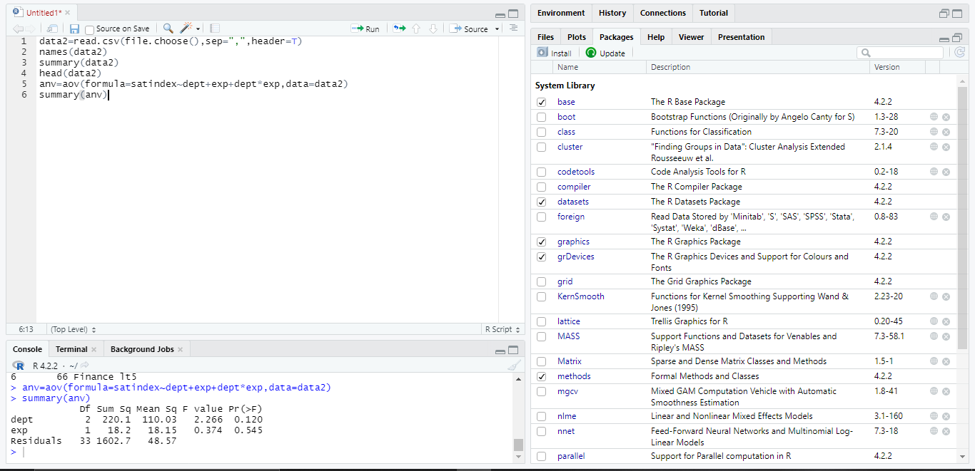

**CONCLUSION:**

The p-value for Department is 0.120 which is greater than 0.05, thus we **accept** H0 i.e. There is no significant difference in the mean satisfaction index between the departments (Finance, Marketing, and Client-Servicing).

The p-value for Experience is 0.545 which is greater than 0.05, thus **accept** H0 i.e. There is no significant difference in the mean satisfaction index between the experience levels (less than 5 years and greater than 5 years).